..
https://www.youtube.com/watch?v=m_SH0TOLsIc
udf

QS
world’s leading provider of services,
analytics
insight to the global higher education sector,

whose mission is to enable motivated people anywhere in the world to
fulfil their potential through educational achievement,
international mobility,
and career development.

2004,
has grown to become the world’s most popular source of comparative data about university performance. Their flagship website, www.TopUniversities.com –
149 million times in 2019

Beyond QS’s publication of the world’s market-leading university rankings portfolio,
Student Survey – the world’s largest survey of the- sentiments,
- motivations,
-preferences of prospective international students.

Their student-facing event series – The QS World Grad School Tour, QS World MBA Tour, and QS World University Tour – gave 225,000 prospective students the chance to meet admissions directors at some of the world’s top universities, across 348 events worldwide.
Throughout the COVID-19 outbreak, QS has transitioned their event offerings online, ensuring that institutions across the world are still able to connect with talent across the globe. QS’s response to the pandemic has also included the development of a series of digital marketing resources for institutions - similarly designed to facilitate continued high-quality engagement with potential students – and the launch of a webinar series empowering university faculty and administrators to share best practices and collaborate as they move their educational offerings into the virtual classroom.
The QS Intelligence Unit – QS’s research and professional services division – provides universities across the world with bespoke comparative performance analysis according to metrics central to each institution’s mission: teaching, research impact, reputational standing, student employability, and internationalization.
They also oversee QS’s international conferences for higher education leaders: these include:
- Reimagine Education – the world’s leading award program and conference for teaching and learning innovation;
- EduData Summit - a space uniting the world’s leading practitioners at the intersection of data and education ;
- QS APPLE – Asia’s foremost convention for higher education leaders;
- A range of subject-focused summits held with QS’s partner universities.
In 2019, as part of their commitment to sustainability, QS became a certified CarbonNeutral® Company, reflecting their efforts to reduce its impact on the environment through a range of efficiency initiatives and offsetting unavoidable emissions through a verified carbon offset forestry project in Brazil.

https://en.wikipedia.org/wiki/Quacquarelli_Symonds
https://en.wikipedia.org/wiki/QS_World_University_Rankings

Dmytro Filchenko, Lead Evaluation Analyst
Alice Wei, Product Manager
Mirela Vlasceanu,

I confirm your video interview with Dmytro Filchenko, Lead Evaluation Analyst, Alice Wei, Product Manager and Mirela Vlasceanu, Product Manager on Tuesday, 1st June at 2pm.

I wish you best of luck for your interview.
Agi

Please see Link for your call
________________________

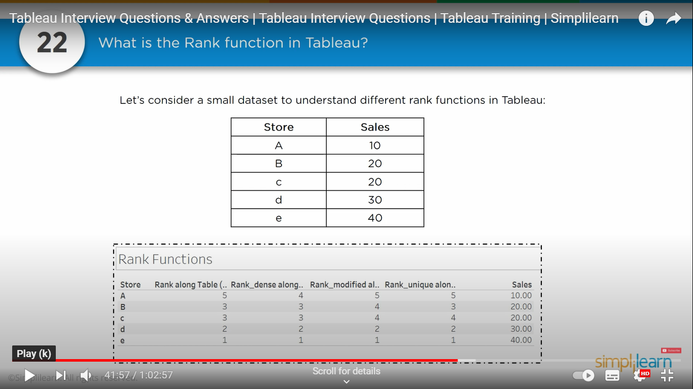

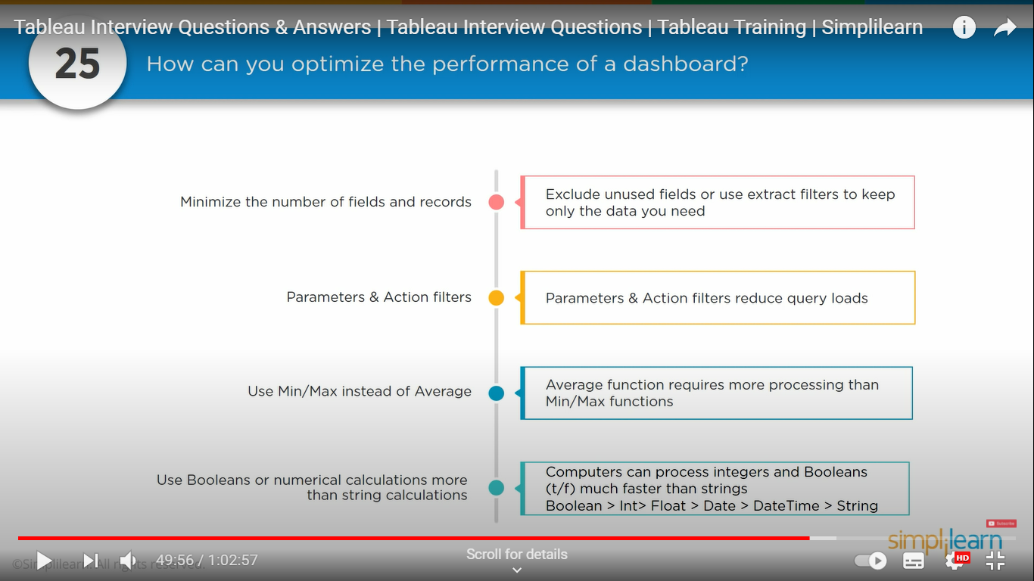

Page 6 of 12
Task 1 – 650 words
Analyse the characteristics of teams.
1.1: Identify the major teams at works in your selected organisation. From among these teams identify the attributes of successful teams.
1.2: Review some theoretical models and select appropriate models to evaluate the teams.
Assessment Criteria
1.1: Identify the attributes of a successful team.
1.2: Review theoretical models and approaches used to evaluate teams.
Page 7 of 1

Task 2 – 650 words
Evaluate methods for team development.
2.1: Evaluate theory for team development.
2.2: Assess the motivational factors affecting different teams in your selected organisation.
Assessment Criteria

2.1: Assess motivational factors affecting different teams.
2.2: Evaluate relevant theory.
Page 8 of 12
Task 3 – 700 words

Evaluate methods of setting team objectives, and monitoring and evaluating team performance.
3.1: Identify and use different approaches to setting team objectives and evaluating team performance for selected teams in the organisation.
3.2: Produce recommendations on how the Team performance could improve.
Assessment Criteria
3.1: Identify different approaches to setting team objectives and evaluating team performance.
3.2: Produce recommendations on how to improve team performance

Hi Deyone,

Instead of saying in a company you have to say in Adidas company there are different teams in finance different team in marketing in a different team in human resources.

similar way every time you saying in a company you have to say in Adidas the team members has to plan 18 members has to organise a team members performance has to be monitored the maximum time

in my guess , I'm not sure 100% sure but my reasonable guess if If you replace the word company And put Adidas who or Adidas company. then you answer become 50 60% relevant.

When you go higher in your Studies or work for a company you have to know the company in and out. At the time when you write a report you have to relate to your company.

It's nearly similar family therapy. A question is asked To you as a family therapist how how the family succeed in the long run.

so you go as a family therapist hotel brands family.

